Most streamed Spotify songs 2023 Analysis using SQL

SQL Queries

1. Top 10 most streamed songs of the year

SELECT track_name, streams

FROM spotify

ORDER BY streams DESC

LIMIT 10;

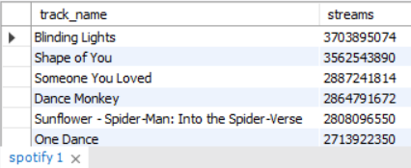

1. Top 10 single artists with most streamed songs

SELECT streams, artist_name

FROM spotify

WHERE artist_count = 1

ORDER BY streams DESC

LIMIT 10;

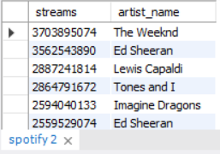

1. Top 10 songs with more than 1 artist

SELECT artist_name, streams

FROM spotify

WHERE artist_count > 1

ORDER BY streams DESC

LIMIT 10;

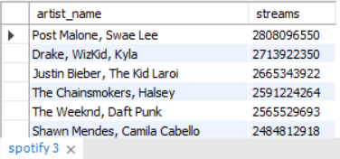

1. Top 10 artist with most song released

SELECT artist_name, count(artist_name)as total_songs_released

from spotify

GROUP BY artist_name

ORDER BY total_songs_released DESC

LIMIT 10;

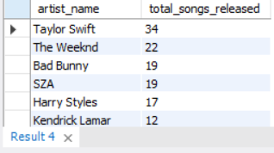

1. Top songs included in the Spotify playlist

SELECT track_name, in_spotify_playlists as no_of_playlists

FROM spotify

ORDER BY no_of_playlists Desc;

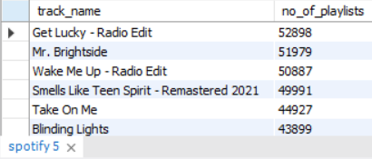

1. Top songs included in the Apple playlist

SELECT track_name, in_apple_playlists as no_of_playlists

FROM spotify

ORDER BY no_of_playlists Desc;

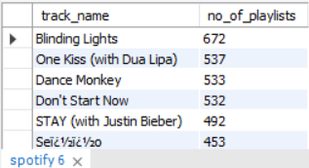

1. percentage of songs as per release year

SELECT count(track_name)*100/(select count(track_name) from spotify)as percentage,released_year

FROM spotify

GROUP BY released_year

ORDER BY percentage desc;

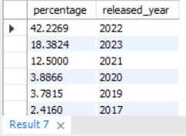

1. Artist(s) with top songs released in 2023

SELECT artist_name, track_name, streams

FROM spotify

WHERE released_year = 2023

ORDER BY streams DESC;

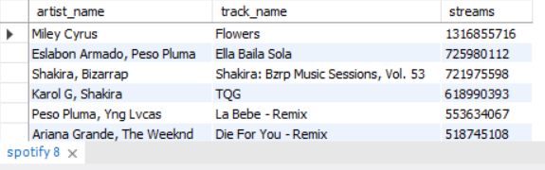

1. Average streams of top 10 artists

SELECT artist_name, avg(streams) as average_streams

FROM spotify

GROUP BY artist_name

HAVING count(artist_name)>5

ORDER BY avg(streams) DESC

LIMIT 10;

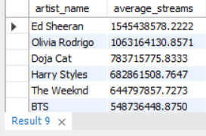

1. Songs with more than 1 billion streams

SELECT track_name, streams

FROM spotify

WHERE streams> 1000000000

ORDER BY streams DESC;

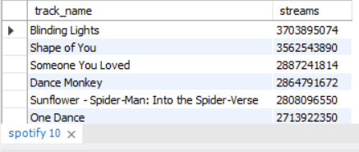

1. Top songs with more than average streams and over 1 artist

SELECT track_name ,artist_name, streams

FROM spotify

WHERE streams> (SELECT avg(streams) FROM spotify) and artist_count>1

ORDER BY streams DESC;

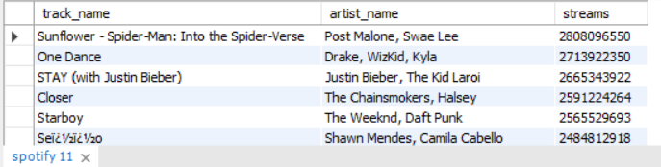

1. Avg streams based on scale

SELECT avg(streams), mode

FROM spotify

GROUP BY mode

ORDER BY avg(streams) desc;

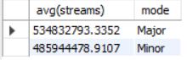

1. Top songs based on danceability, valence and energy

SELECT track_name, streams, `danceability_%`, `valence_%`, `energy_%`

FROM spotify

WHERE `danceability_%`> (select avg(`danceability_%`) from spotify) and

`valence_%`> (select avg(`valence_%`) from spotify) and

`energy_%` > (select avg(`energy_%`) from spotify)

ORDER BY streams desc;

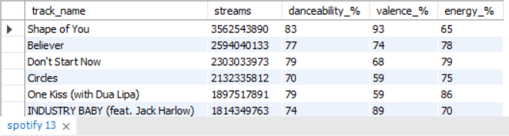

1. Top songs based on liveness and speechiness

SELECT track_name, streams, `liveness_%`, `speechiness_%`

FROM spotify

WHERE `liveness_%`> (select avg(`liveness_%`) from spotify) AND

`speechiness_%` > (select avg(`speechiness_%`) from spotify)

ORDER BY `liveness_%` desc, `speechiness_%` desc;

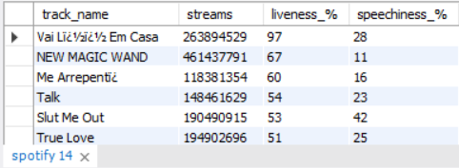

1. Most acoustic and instrumental songs

SELECT track_name,streams, `acousticness_%`, `instrumentalness_%`

FROM spotify

WHERE `acousticness_%`> (select avg(`acousticness_%`) from spotify) AND

`instrumentalness_%` > (select avg(`instrumentalness_%`) from spotify)

ORDER BY `acousticness_%` desc, `instrumentalness_%` desc;

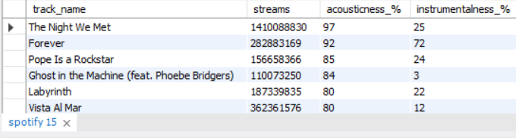

CONCLUSION

After analyzing the data, we can say that a lot of people are still listening to the songs made in 2022 and 2021 with combined percentage of 54.7%. Only 18% of the songs are made in 2023. People slightly prefer songs made in Major scale to minor scale. The most popular song made in 2023 is Flowers by Miley Cyrus. According to the dataset, the artist with most popular song released is Talyor Swift with 34 most popular song followed by Weeknd and Bad bunny with 22 and 19 respectively. The artist with highest average streams is Ed Sheeran, Olivia Rodrigo and Doja Cat. Overall, the most popular songs were Blinding lights, Shape of you, someone you Love, Dance monkey, Sunflower.